Jalu Chaudhary

Class IT-314-DL1

Hand on Assignment: Procedures

**Assignment 5-10: Returning a Record**

Create a procedure named DDPROJ_SP that retrieves project information for a specific project

based on a project ID. The procedure should have two parameters: one to accept a project ID

value and another to return all data for the specified project. Use a record variable to have the

procedure return all database column values for the selected project. Test the procedure with an

anonymous block.

**Assignment 5-11: Creating a Procedure**

Create a procedure named DDPAY_SP that identifies whether a donor currently has an active pledge

with monthly payments. A donor ID is the input to the procedure. Using the donor ID, the procedure

needs to determine whether the donor has any currently active pledges based on the status field

and is on a monthly payment plan. If so, the procedure is to return the Boolean value TRUE.

Otherwise, the value FALSE should be returned. Test the procedure with an anonymous block.

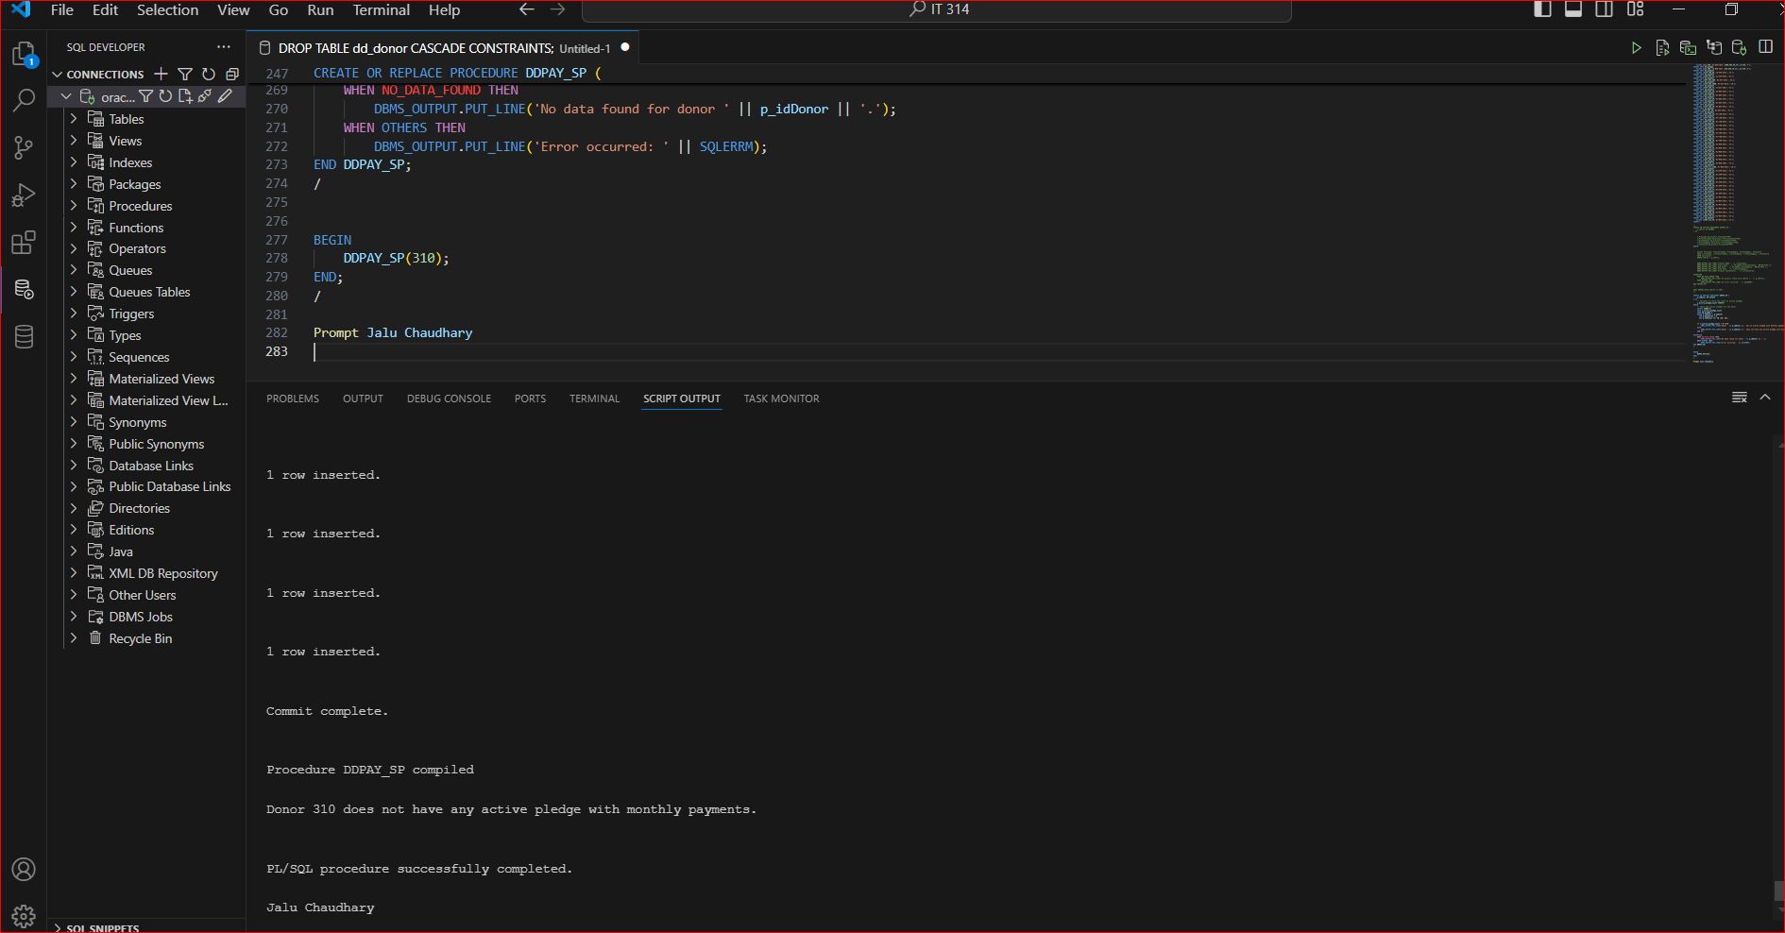

**Assignment 5-12: Creating a Procedure**

Create a procedure named DDCKPAY_SP that confirms whether a monthly pledge payment is the

correct amount. The procedure needs to accept two values as input: a payment amount and a

pledge ID. Based on these inputs, the procedure should confirm that the payment is the correct

monthly increment amount, based on pledge data in the database. If it isn’t, a custom Oracle error

using error number 20050 and the message “Incorrect payment amount - planned payment = ??”

should be raised. The ?? should be replaced by the correct payment amount. The database

query in the procedure should be formulated so that no rows are returned if the pledge isn’t on

a monthly payment plan or the pledge isn’t found. If the query returns no rows, the procedure should

display the message “No payment information.” Test the procedure with the pledge ID 104 and the

payment amount $25. Then test with the same pledge ID but the payment amount $20. Finally, test

the procedure with a pledge ID for a pledge that doesn’t have monthly payments associated with it

